Touchstones
Nonviolence November 2021
Have you noticed? I have. People seem so angry. Tempers too often at the surface. Violence – linguistic and physical – feels like a first option instead of a last one.

You see this in way people talk about their political enemies – especially on the reactionary right, which had pretend scaffolds for executions at the attempted insurrection on January 6th, and where a cult of guns and violence seems rampant. But you also see it in the rising number of murders nationwide. You see it, I think, in the rising car accidents too – aggressive driving, “who cares who gets hurt?”

But I see it too in more subtle ways. The way folks don’t seem to notice each other. Dehumanizing language (which I’ve heard from folks in all political positions, including on the left). Fights in schools, and a winner-take-all-so-I-better-hit-first approach by many adults. Insults and attacks (and of course, the power-reinforcing “can’t you take a joke” response when called to do better.).

It’s violence, and a lack of empathy, and anger. Why?

Like many things, the pandemic accelerated some existing trends. Social isolation, polarization, and hopelessness often come dressed as rage. For many male-identified people, rage is what we express when we don’t feel safe enough to be sad. There’s plenty to be sad and angry about: the climate crisis, racism, inequality, and our creaky and unresponsive government.

But rage is also being deliberately fed by those who profit from it. That includes many media outlets and politicians. And it very much includes Facebook; recently it was revelated that Facebook’s algorithm gives five times as much weight to an “angry” reaction to a “like” reaction. Anger leads to engagement, engagement leads to clicks, clicks lead to profit.

Our topic this month is non-violence, and it is clear we are in need of more non-violence. And this cannot be a surface thing but must be a deep thing. What might produce a life and a culture of non-violence instead of a culture of violence?

Patience is clearly one of those things. Rage often comes from rushing. Slowing down allows space for the great antidote to violence to rise empathy. When we recognize the humanity of one another (including folks who make us enraged) we can turn away from violence. The other thing that would clearly produce less violence is justice. This is a point that Dr. King and others have made often: injustice is violent, and justice is non-violence. When those who break the social bonds, who abuse others and their own power, and who commit violence are held accountable, then violence dissipates. But when “they get away with it”, often rage is all we are left with.

But the main thing that builds a culture of non-violence is love. Love is the deeper form of empathy, it is not just seeing one another’s humanity, but it is earnestly desiring the well-being of others. It is love for ourselves and those we encounter that can move us to build a non-violent life and a non-violent society.

So, when you notice rage in you, I invite you to explicitly invite love into your heart at that moment – love for yourself and for others. That love might move you to justice – to calling in or even calling out those who do harm – but love will never move you to violence.

I look forward to our conversations this month on this topic.

In faith,
Rev. Matthew

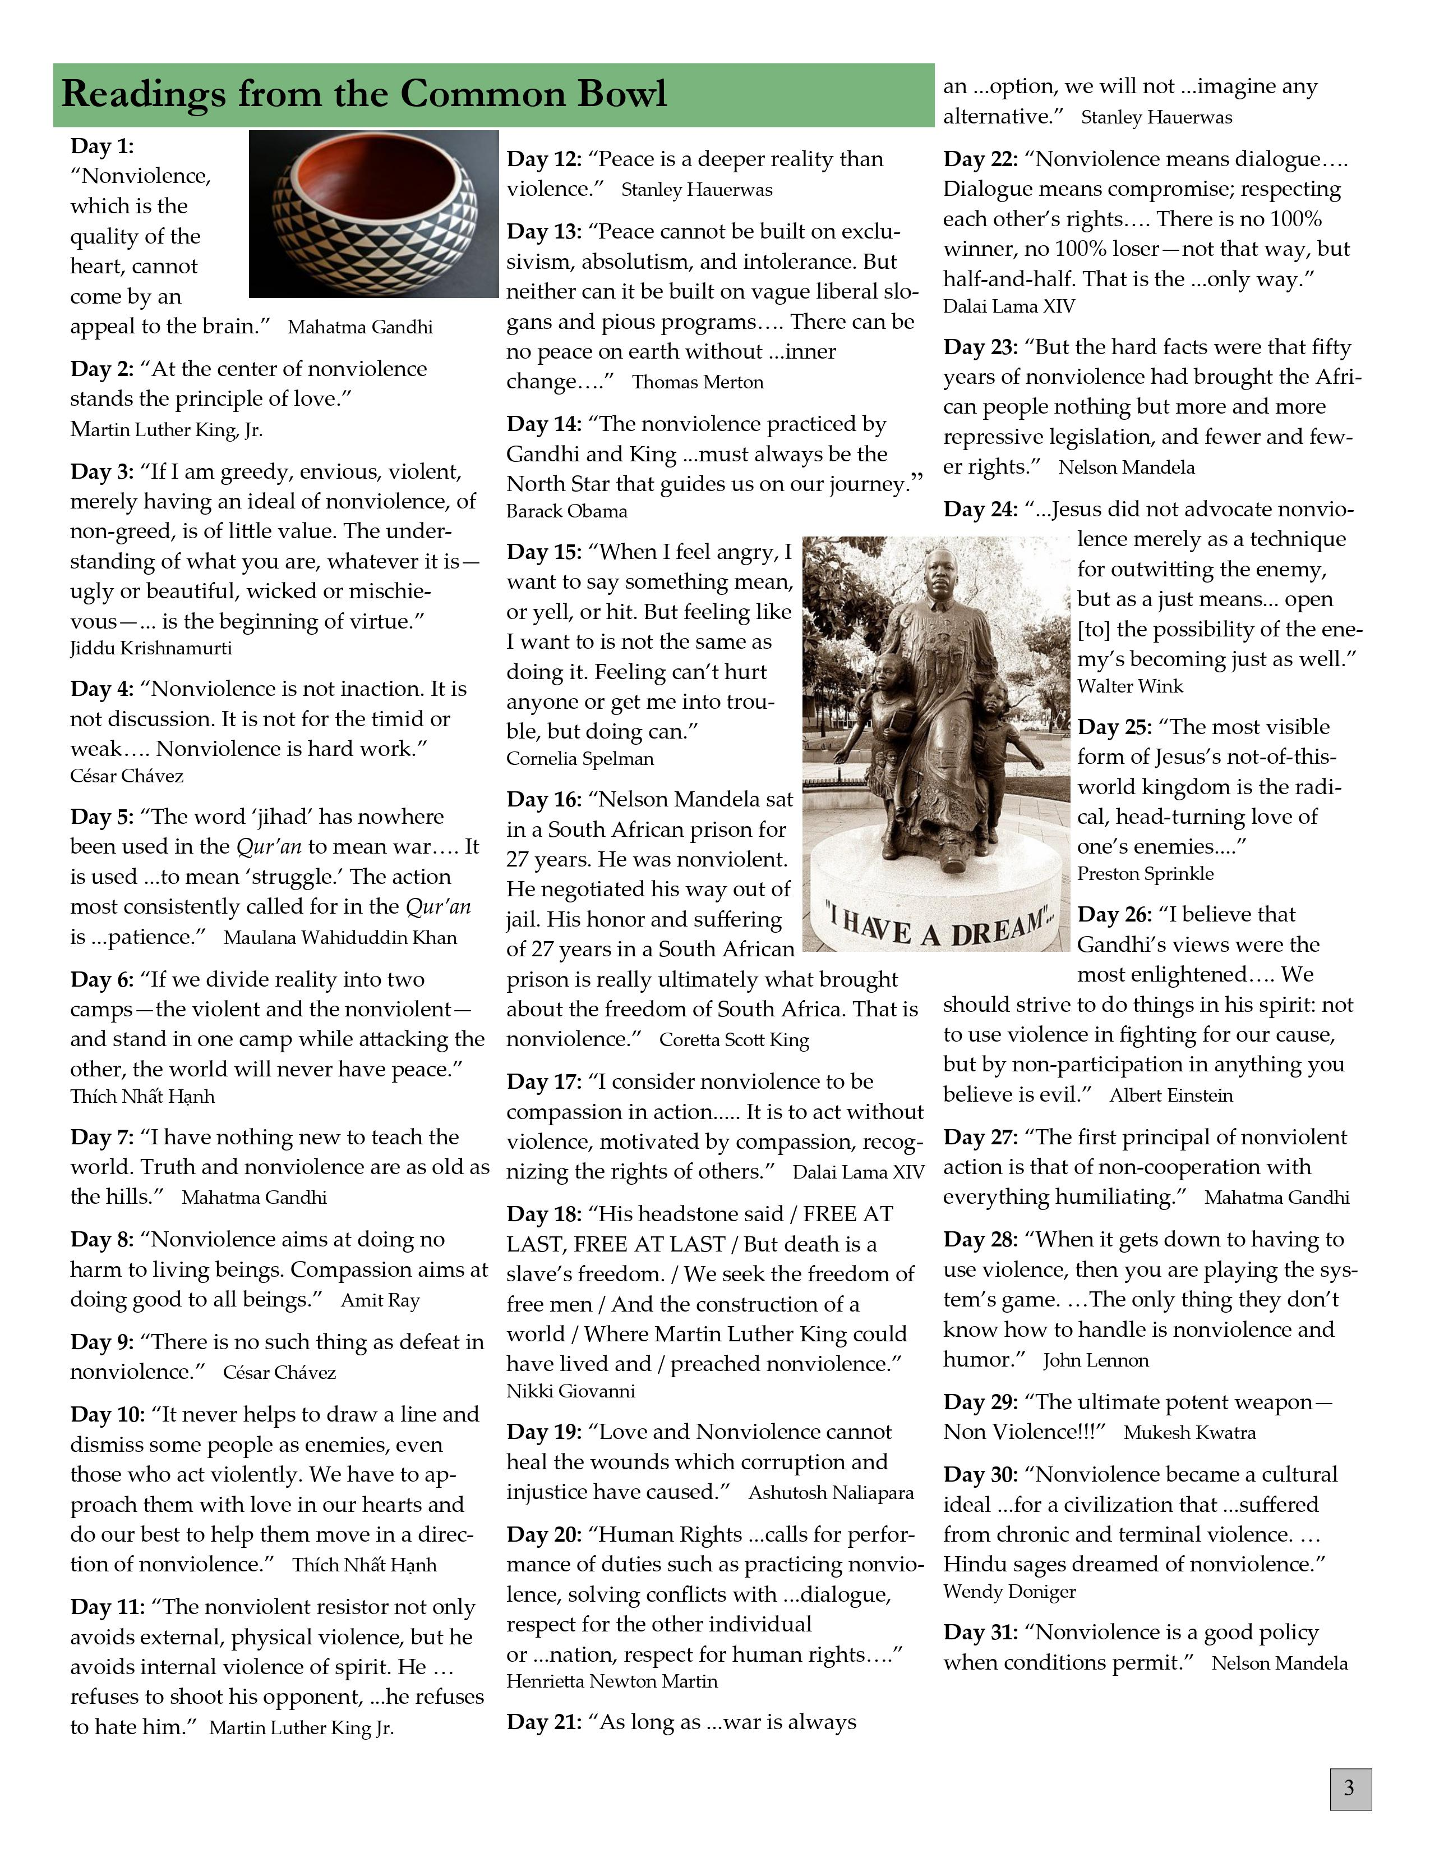
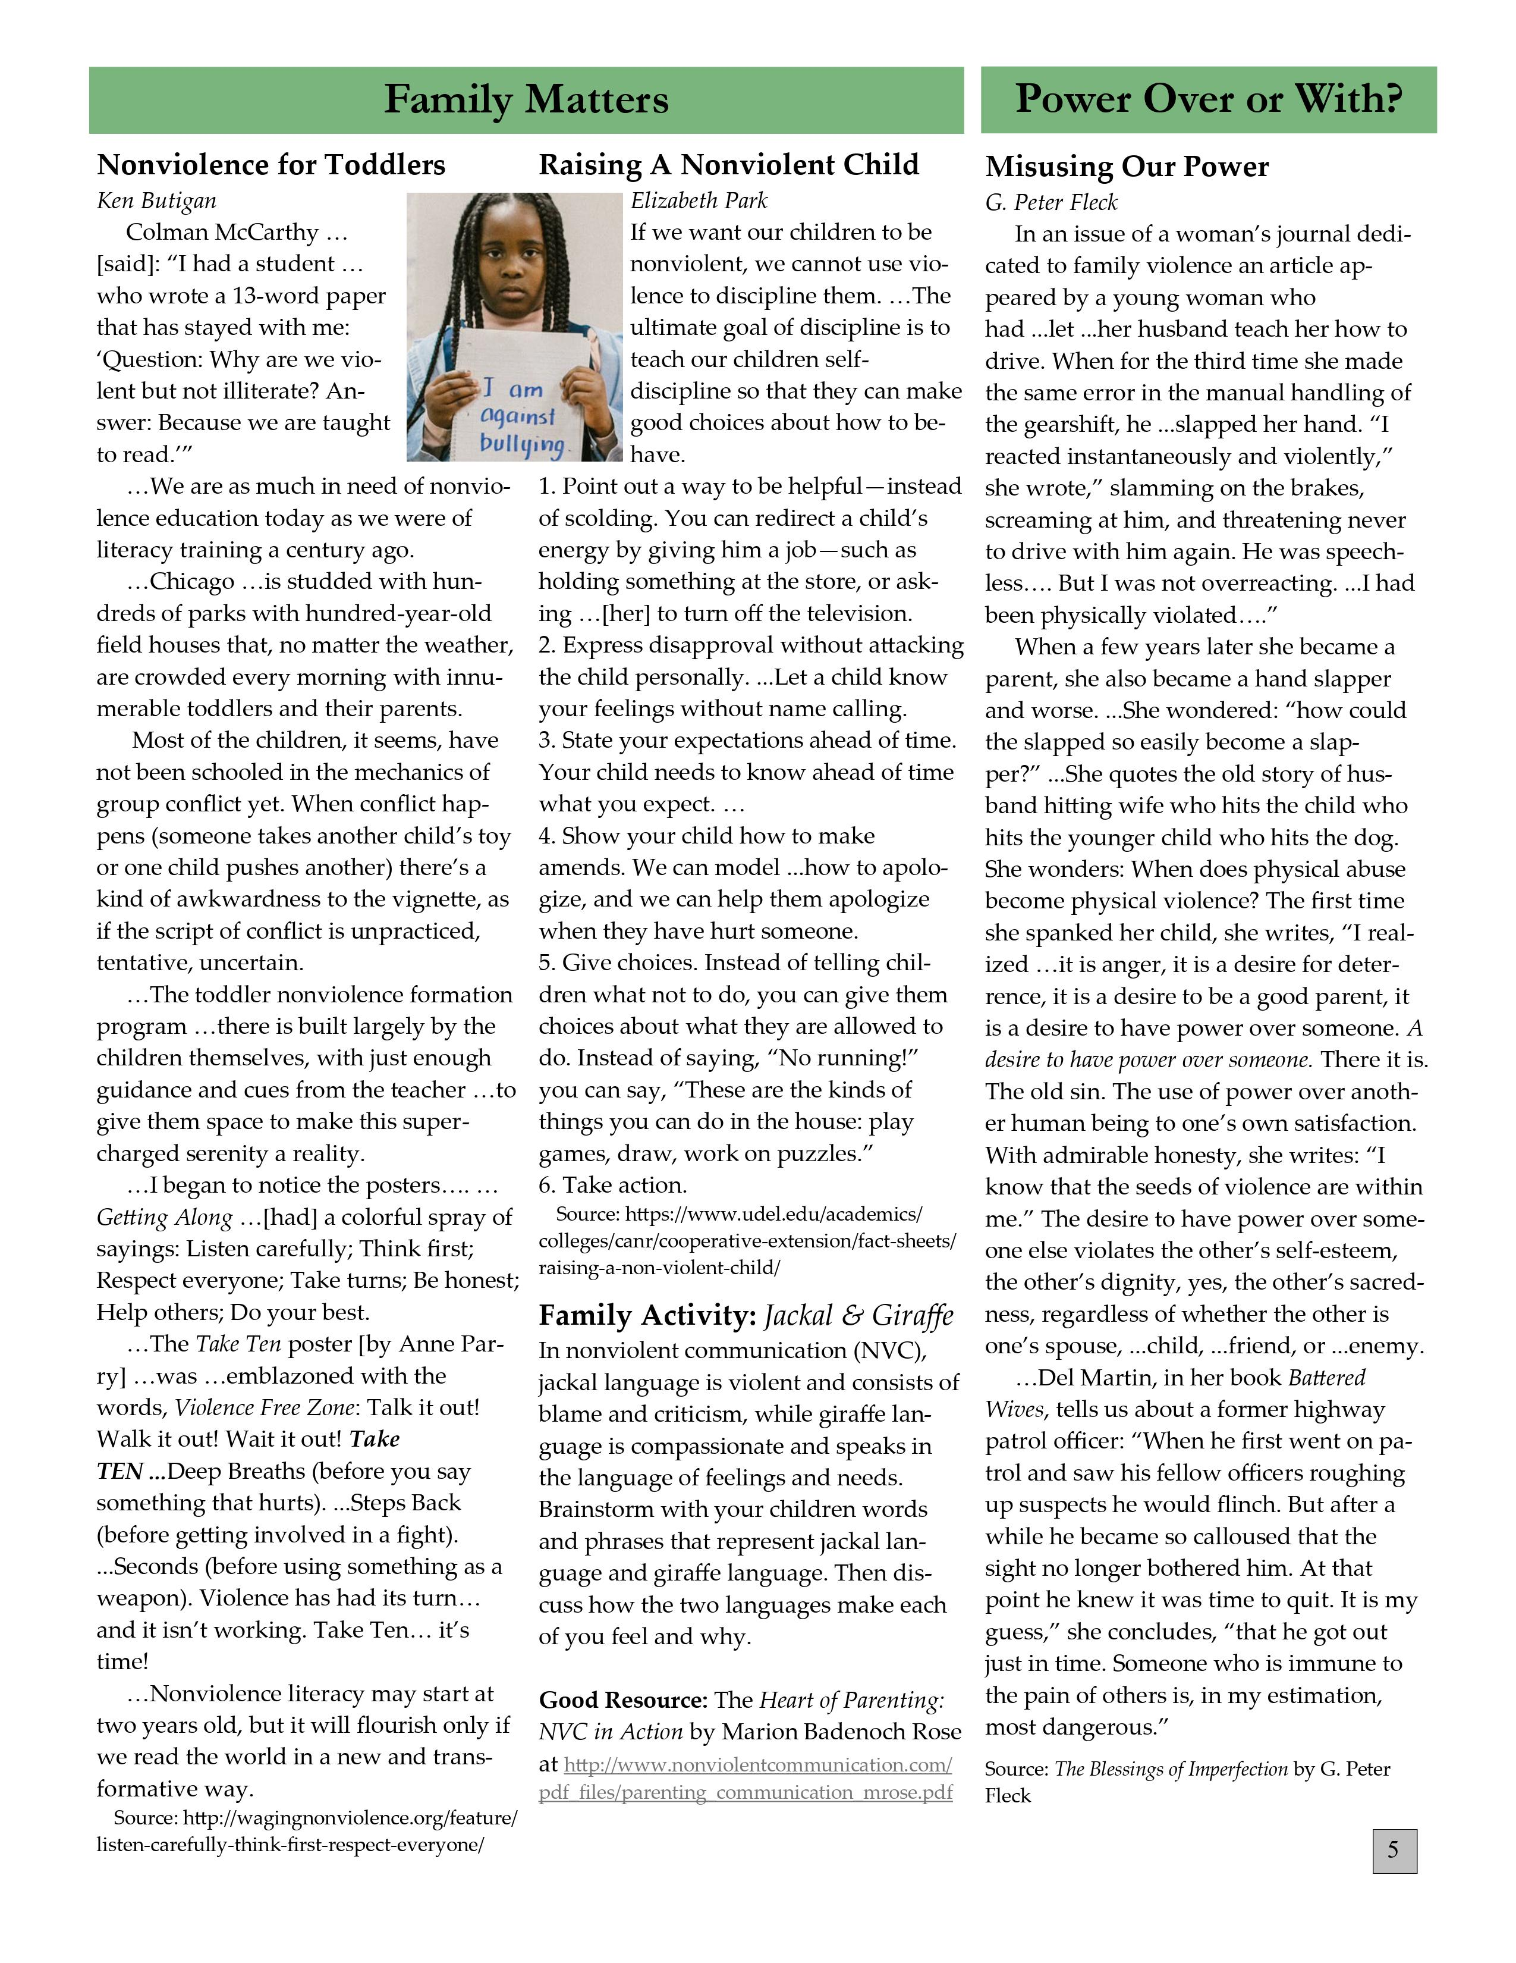

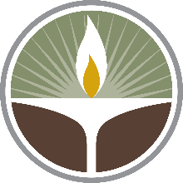
The Unitarian Universalist Church
4848 Turner St.
Rockford, IL 61107

Nonviolence & Repairing the World
It should be obvious that violence can never repair the world. At the extreme, we have war. Notably, Just War theory does not argue that war is good. A “just” war is “permissible” only because it’s a lesser evil, but it’s still an evil. And evil is always destructive. The problem is that there is so much violence: bullying, domestic violence, child abuse, gun violence, suicide and self-harm, date rape, racism, and more. Even poverty and homelessness are forms of violence. So, nonviolence is a tool to inform how we repair the world. It requires compassion, a commitment to justice, creating movements to oppose the violence, employing power in creative ways, having a vision of what could be, and perseverance.

- Members and friends of the church who live at Wesley Willows are invited to join others and Rev. Matthew on the 4th Tuesday of most months. Our next meeting will be November 23 at 9am. We will meet in the fellowship hall at Aldersgate United Methodist Church.
- Touchstones: contact your touchstones group facilitator for the time
and meeting ID, if you do not already have it.

Want to have a group – a book group, a parent group, a “circle supper”, or whatever you like?
– just email Autumn at office@uurockford.org and she can give you the Zoom login and password

